SKETCHING – OBJECT DRAWING

Sketching, more contextually, Object drawing is essential for the representation of 3 Dimensions of an object. Students, through this course, will gradually grasp an understanding of how best they can communicate their ideas through a sketch in the most appropriate way.

What makes for a good sketching?
• It communicates
• It is proportionate
• It looks three-dimensional
• It resembles the real object or product concept.

This course has a do -it -yourself module on Product Sketching will take the students through:
• Methods of pencil drawing, through exercises to coordinate eye and hand movements to acquire necessary skills to improve the quality of line drawing
• Drawing in perspective, i.e. one-point and two-point perspectives
• Drawing by looking at objects in a stable, correct perspective and right proportions
• Drawing objects from memory with correct perspective and proportions
• Drawing of shadows for the objects
• Drawing of highlights for objects
Note: Here is a short checklist of the essential tools that are needed for the Exercises mentioned within the chapters.
- Paper: Regular A3/ Drawing Sheets.
- Stationery: Pencils: HB,2B,4B,6B, etc. Soft pencils are preferred. For the latter exercises on object rendering - pencil color’s, dry pastels, or crayons.
- Posture: Students must remember to keep the drawing surface perpendicular to the eyes.

Examples:

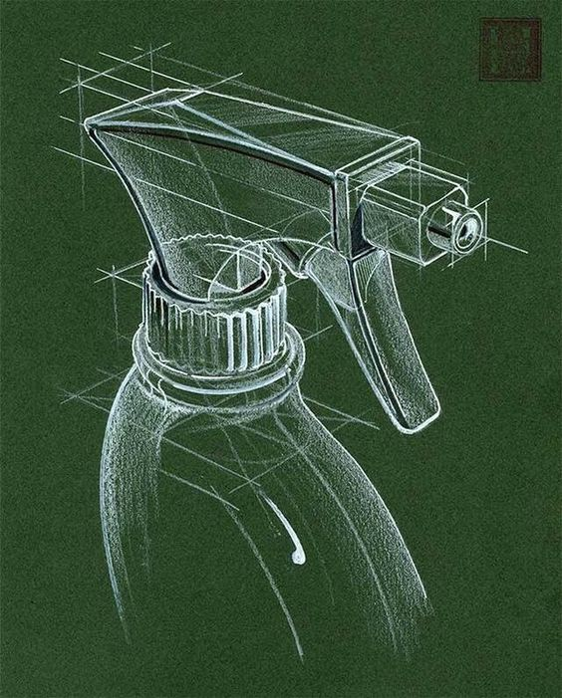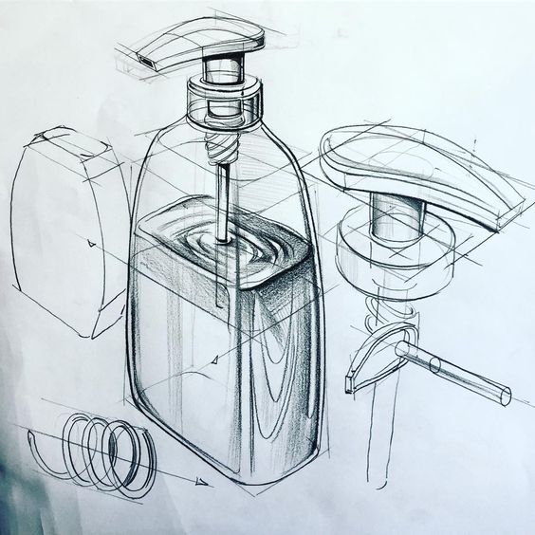

Detailed pencil Drawing

Lines and Basic Shapes:

Good sketching is mastering the lines. This will lead to good line quality through better mind-body coordination for fluent and confident hand movement when the students begin to draw more complex objects, especially in perspective.

Exercise 1: The aim is to improve line quality and control over the pressure on paper and pencil.
Posture Tip: Make use of full hand as well as the body movements to draw the line.
• Draw a straight line, Horizontal Lines, Vertical Lines, Diagonal Lines, Pattern Lines across the sheet.

Straight Horizontal Lines Closely spaced Straight Lines

Straight Vertical Lines Diagonal Lines

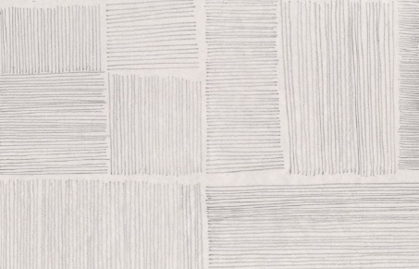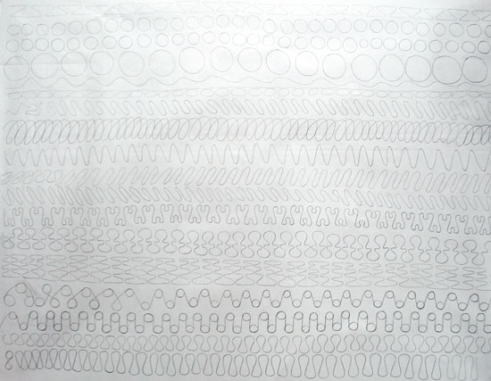

Pattern Lines. Waves

Circles

Product Sketching:

Good Product Rendering requires both practice and skill. Proportionate, well-defined sketches and renders communicate best. Pencil sketches done using good shade, shadow and highlight techniques or renderings in crayons, dry pastels, etc. are highly effective visualization tools for the designer. Well thought of angles of view of the product, that gives maximum information about it, and covers most details are ideal. At times, students could also opt for more than one view, depending on their product, so as to communicate all aspects of their concept well.
For rendering, one good technique is to select a base color that comprises most part of the product’s body. This allows the students to just play with the shadows and highlights, instead of bothering about the fill. Also observe how a reflection on an object will follow the contours of that object.

Object Rendering:
Gradually, students are made to take up more complex objects for rendering that demand greater detailing such as varied textures or materials

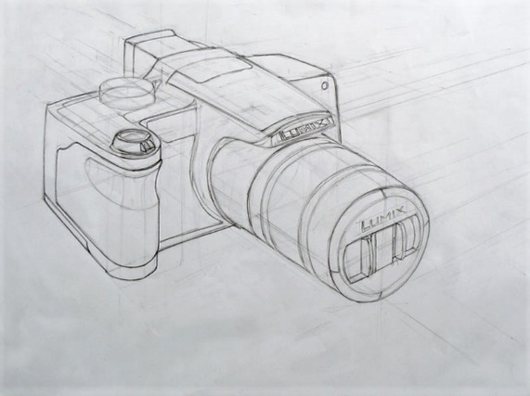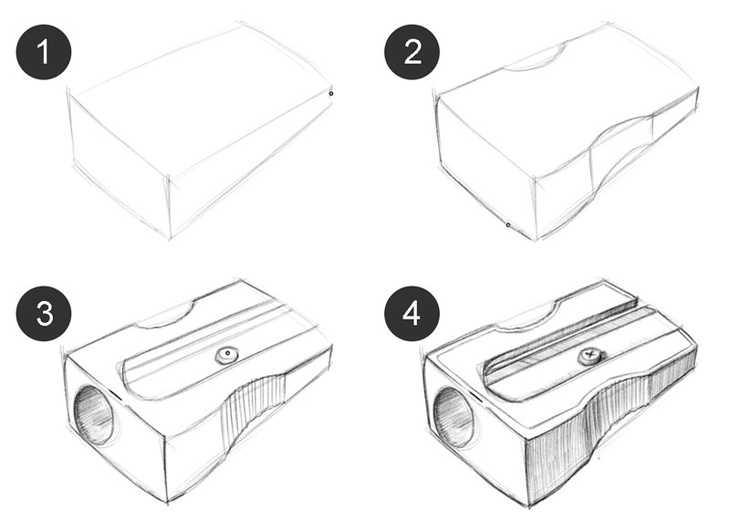

Product sketching: object Drawing and steps

Shadows:

Shadows help make the sketches ‘pop-up’ from their backgrounds and seem more real. It is important to understand light in order to understand shadows. It is best to begin with Shadows of objects with single light sources. The simplest way to trace a shadow is to draw straight lines starting from the assumed source of light/lights to the edges or corner most points of the product, extending it beyond to fall onto the surface or ground on which the product is kept. In case of complex objects, shadows may be cast onto the same product surface and follow the profile of the surface. Thus, shadows also enhance the overall sketch giving more information of the surface it falls on, be it the ground, or on itself.

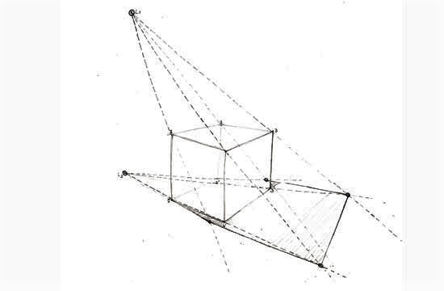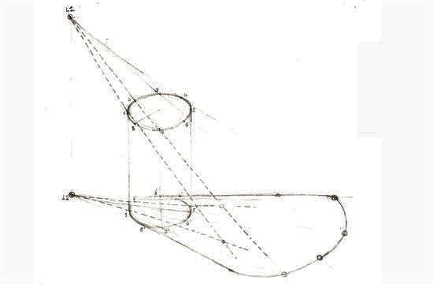

Students are made to observe how the shadows have been traced from the end points of the cube and cylinder in these cases.

Students are made to observe how the shadows have been traced from the end points of the cube and cylinder, complex shape in these cases.

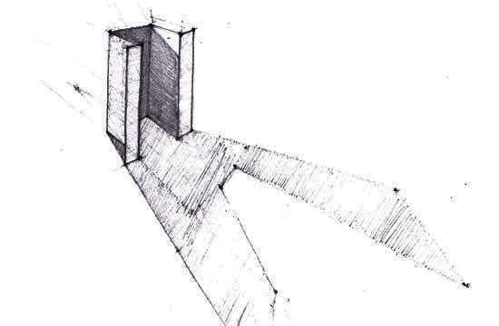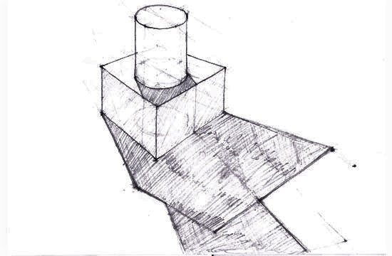

Note:
Students are made to try the same method for more than one source of light.

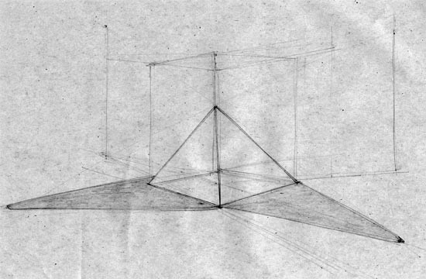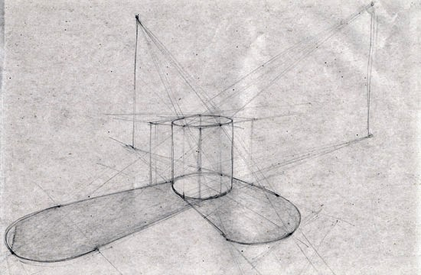

Note the shadow trace for the pyramid and the cylinder

Note: Students are made to assume a light source above eye-level and draw the shadow of a cube, taking references from aforementioned examples.

Highlights:

Highlights are used to grab attention or create focal points for the observer by virtue of the reflections. They also help define form without one having to filling in or fleshing out the whole thing. They are the brightest spots on the object as light reflects most there.

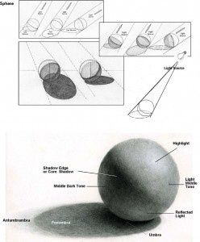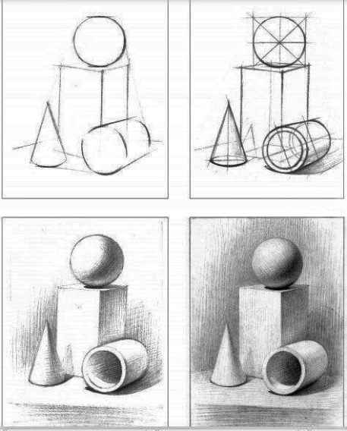

Perspective

Understanding perspective is essential to be able to represent three-dimensional objects with correct proportions, which are more realistic and ‘true’ to the eye. One basic difference between isometric product drawings and product sketching is the visual effect of depth that is achieved through foreshortening.
Foreshortening: Foreshortening is distortion due to perspective when an object appears compressed when seen from any particular viewpoint.
Vanishing Point (VP): Due to foreshortening, if we were to extend these lines of taper, there would appear a point where these lines seem to emerge from, this point is called the vanishing point (VP), as elucidated in Fig.
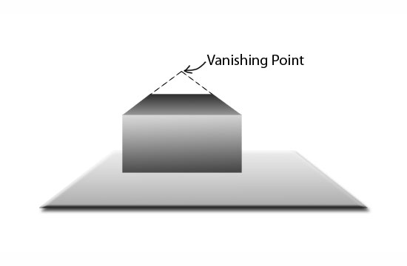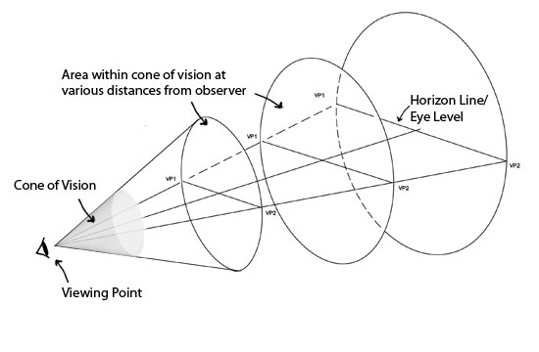

For more clarity on the vanishing point, Students are made to hold an object in front of their eyes, and gradually move it away towards left and then to right, up and then down and are asked to notice that beyond their cone of vision, the object vanishes. This perimeter region, beyond which the object vanishes from their view, is where the vanishing points lie.

Note: One and Two Point Perspectives make use of one and two vanishing points respectively.

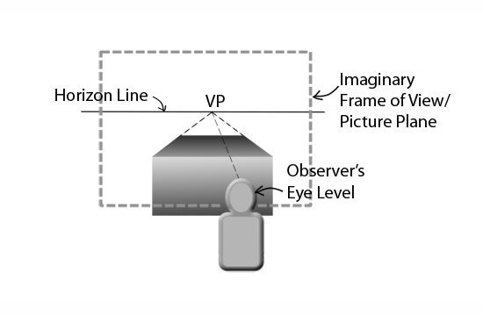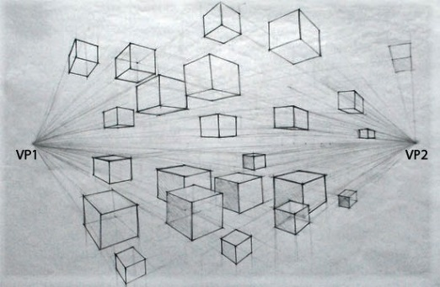

One Point Perspective Two Point Perspective

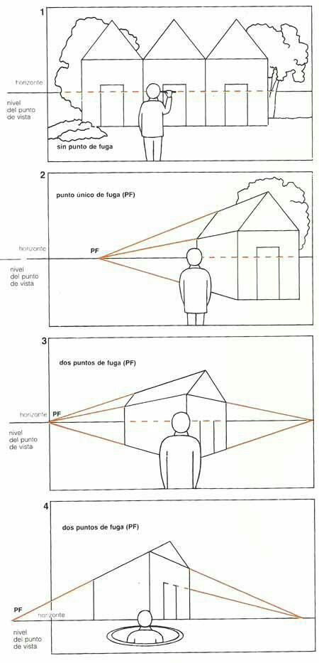

One Point Perspective: In One Point Perspective, also known as Parallel Perspective, the object is directly in front of the observer and not at an angle such that its primary surface is parallel to the imaginary frame of view or picture plane. Mostly adopted to draw spaces, such as interiors of a room or buildings on a street, one will notice that the objects diminish in size, perpendicularly into the paper towards this single vanishing point.

Two Point Perspective: Two Point Perspectives, i.e. perspectives drawn considering two vanishing points are mostly adopted for object drawing. Designers adopt Two Point perspectives for most of their 3D representation.

Three Point Perspective: Three Point Perspectives, i.e. perspectives drawn considering three vanishing points are mostly adopted for extreme object drawing. Designers adopt Two Point perspectives for most of their dramatic and extreme 3D representation – for highligighting.

An Explanatory image showing
1, 2 and 3 - Point perspective

Exploded Views

It is good to have an idea about exploded views as they come in handy while detailing out various parts of the product concepts and communicating as to how they connect to become a single entity. They represent the relationship or order of assembly and contain all details of the product’s component parts.

Examples:

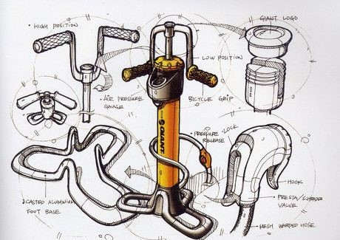

An exploded view of a design of a bicycle air pump

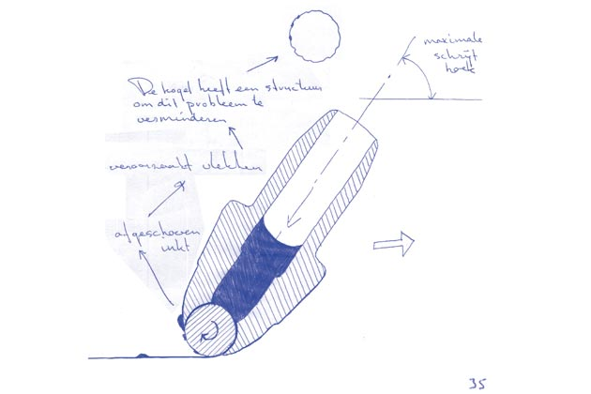

An Explanatory Sketch explaining the functioning of a ballpoint pen

